**What is matching?**

Two integrated device or more have same desired value are exposed to the same conditions whether pressure, temperature, current etc.

**Why need matching?**

What if your headphones started playing songs with more volume in left than the right? Sounds bad right. So, the voice sensitivity needs to be matched for both left & right side by same.

Actually, due to process variation in fabricating the transistors (like non uniform doping, oxide thickness, etching etc.), no 2 transistors have exactly the same electrical properties. By applying techniques such as Interdigitzer & Common centroid, it is possible to match transistors reasonably

In a sensitive amplifier (differential pair), matching would greatly enhance the performance by improving the ability to reject noise in its differential input.

**How to do matching?**

We can achieve matching when avoid mismatch sources and use relative accuracy Mismatch is a deviation of values of integrated component after fabrication desired value used for simulation Let’s assume we want design low pass filter in 1MHZ

$ω=\frac{1}{RC}$ in simulation design $R=1kΏ$, $C=1nf$

after fabrication process $R=1.3kΏ$, $C=1.3nf$, $ω=0.6MHZ$

**We will identify the most prominent sources of mismatch**

* Process Variations
* Placement and Gradient
* **Mismatch (Process variations)**

Process variation during fabrication process limits accuracy and desired performance of analog circuit:

* + **mask production and alignment**
  + **latera diffusion**: Diffusion widens implanted region can affect doping of neighboring devices. Solution: Increase distance and use dummy structures that affect all transistors the same.
  + **over etching**: Poly silicon does not always etch uniformly.

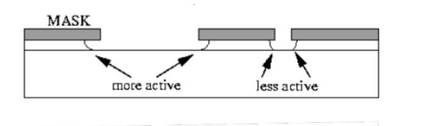

* + Large openings etch faster than small openings in mask. Solution: is to use dummy structures.

And all of this effects on Dimensions of device $\frac{W}{L}$ Ratio and consequently the threshold voltage value will change with it.

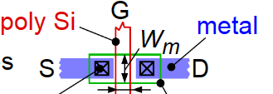

* + - Mismatch (Placement and Gradiant)
    - Orientation
    - Stress gradient: occurs mainly from wafer dicing where stress is highest at edge of the chip, Packaging can cause stress in chip. Solution: Keep critical matched devices in center of chip , Avoid using corners for matched devices

* + - Temperature gradient We use matching so that the devices are exposed to the same thermal effect

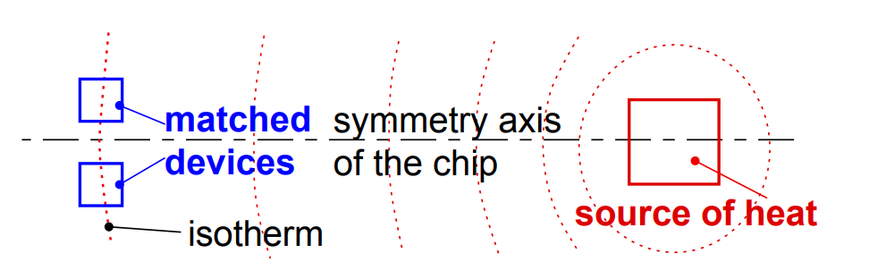

**Rules for optimum matching:**

**Devices to be matched should have:**

1. Same structure
2. Same temperature
3. Same shape and same size
4. Minimum distance
5. Common centroid geometries
6. Same orientation on the chip
7. Same surroundings (same neighbourhood)
8. Non-minimum size

**Rules for optimum matching:**

**Devices to be matched should have:**

1. Same structure
2. Same temperature
3. Same shape and same size
4. Minimum distance
5. Common centroid geometries
6. Same orientation on the chip
7. Same surroundings (same neighbourhood)
8. Non-minimum size

**Rules for optimum matching:**

1. **Minimum distance**
2. **Same surroundings (same neighbourhood)**

When we see in this figure of two transistor, We see that the transistors have been placed directly next to each other. Good in terms of distance however, if you continue thinking about these two transistors, you notice another problem.

For a CMOS transistor, the parameters that most affect the characteristics of the transistor are the gate length (L)and the gate width(W). Some etches used in processing etch preferentially in one direction. That is the problem. One device is placed sideways. What etching errors occur in one transistor’s width, will occur in the other transistor’s length.

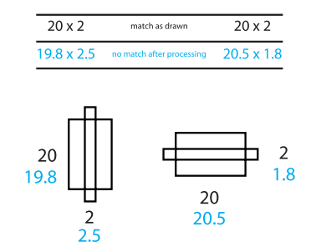

After etching process we found one device width equal 20.5 and other 19.8

1. **Same orientation on the chip**

If we follow these three basic rules, throughout all of our layout, we are guaranteed a certain amount of good matching, plus the advantage of better device performance. There will be times when trying to keep all our transistors, resistors, and capacitors in the same orientation makes your layout very difficult in this case can split up and reshape our devices , There will be times when we cannot split our devices sensibly, or we are not allowed to. In these cases, how much we know about what the circuit is doing can help our layout. Find out what components are the least important in the circuit and maybe, just maybe they can be rotated to make your layout smaller.

For example, you might have a problem device that just will not fit well in our layout. If you think the device is non-critical, it may be a good to rotate. Go to our circuit designer and ask, “Is it ok to rotate this transistor?” communicate with our circuit designer help us to find suitable solutions.

1. **choose appropriate unit to be used in matching**

Sometimes we have more than two devices that must match each other. There might be five or six devices, all needing to match.

First step we can use is placing the resistors as close together as we can, second step is to keep them in the same orientation, third step is called a root component I mean one resistor from which you will make all the others. Using a root component, if the resistors are all the same size, all the same shape, and all the same orientation, and they are all close to each other, you get very good matching. If the resistors over-etch, they all over-etch the same way and still match each other.

For example

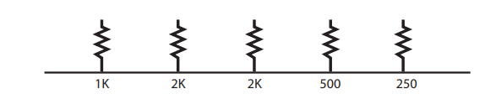

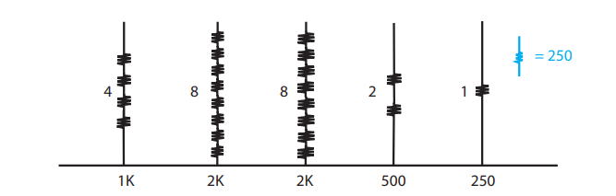

if use $250Ω$ It is good but in this example we have some large resistors, like the $2KΩ$ resistor, for instance. Consider this, contacts on a resistor are typically quite variable and using a $250Ω$ resistor as the root component could have a significant portion of its resistance made up from contact resistance. The contact resistance could then create a significant amount of the total resistance on your larger resistors, which have eight times the number of contacts.

So, we Choose a middle value for our root component:

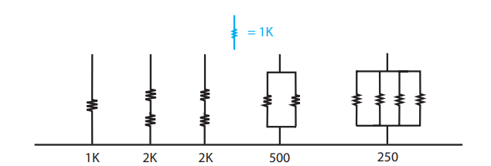

If use 1k better way to use the root component strategy is to pick a medium value. Let’s pick one from our previous example. Let’s choose 1K as our root resistor. The 2K’s would each be two resistors in series. The 500-ohm is two resistors in parallel, and the 250 would be four resistors in parallel. We have made all our required values based on a 1K resistor. We used both series and parallel arrangements.

The root device method can be used with any type of device, not only resistors. The same issues.

**Summery Rules for optimum matching:**

Devices to be matched should have:

1. Same structure
2. Same temperature
3. Same shape and same size
4. Minimum distance,
5. use relative accuracy not absolute(true) accuracy.
6. choose appropriate unit size.

**How the matching method is actually applied?**

There are two common way :

1. **inter-digitiation**
2. **common centroid**

Let's say we have two devices A,B )A and B can be anything likes transistor, resistor, and capacitor) and split A and B into 4 small multipler A1-A4 and B1-B4. **Inter-digitization technique**: Placing alternate components.

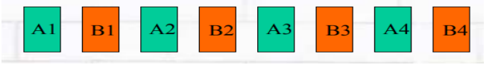

**Common centroid technique**: all components have same centroid.

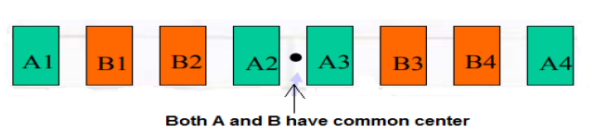

Example of the two way

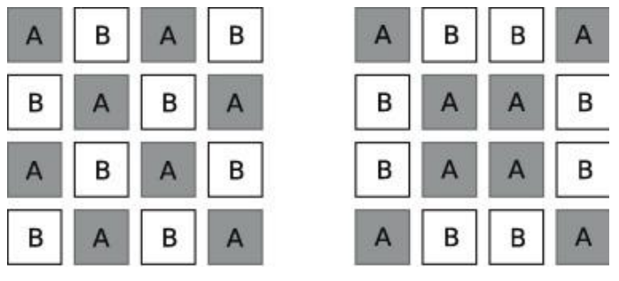

Inter-digitation common centroid